NEXT TIME, BOOK YOUR APPOINTMENT ONLINE!
It’s so easy. Just go to our website (thephysionook.com.au) from your computer, tablet or smartphone and click the button that says
“Book your consultation”.
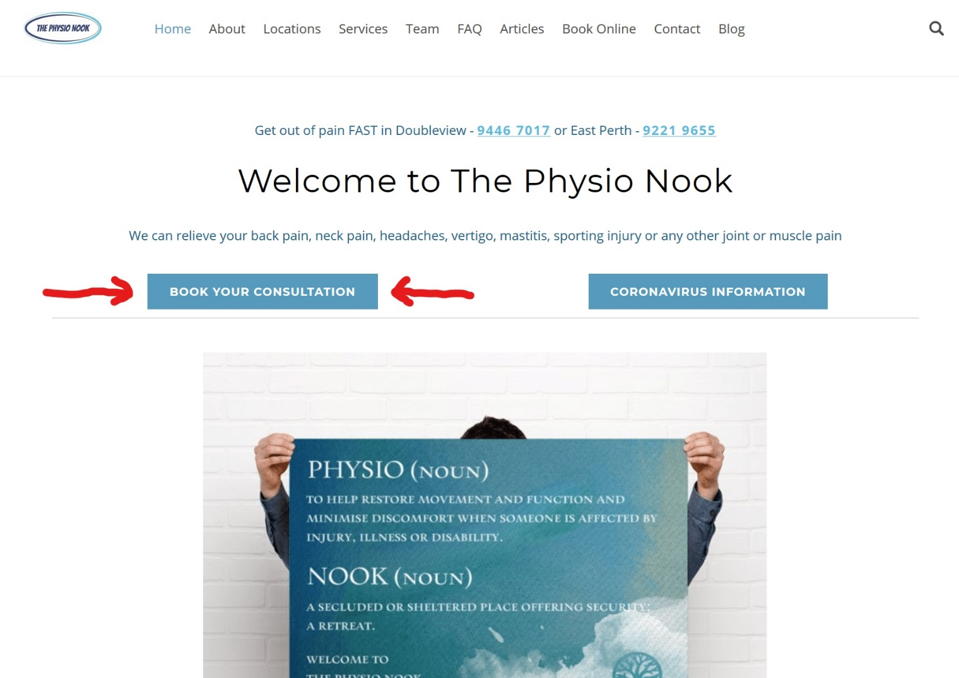

You can also do it from our Facebook page
(search for The Physio Nook) and clicking on the “Book now” button under the cover picture.

We hope this extra convenience helps you!

